**Name : ___________________________ Date : _________________**

**For Loops Worksheet 1**

**Show the output of each block of code below.**

1. What is the output?

for(int i=1; i<15; i=i+3)

{

out.println(i);

}

2. What is the output?

for(int j=11; j>-2; j=j-2)

{

out.println(j);

}

for(int x=20; x<40; x=x+3)

{

out.println(x);

}

3. What is the output?

for(int m=30; m>0; m=m-4)

{

out.println(m);

}

4. What is the output?

5. What is the output?

int total=0;

for(int s=1; s<15; s++)

{

total=total+s;

}out.println(total);

**Name : ___________________________ Date : _________________**

**For Loops Worksheet 1**

1. Write the for loop that would draw the following picture:

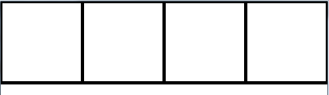

2. Write the for loop that would draw the following picture:

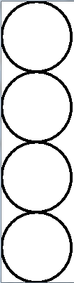

3. Fill in the blanks in code below so that the pentagon on the right will be drawn:

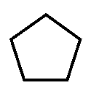

translate(width/2,height/2);

strokeWeight(4);

rotate(-PI/2);

______________;

for(float theta = ____;theta < ______; theta+=2*PI / ___)

{

float pX = ___________ * 50;

float pY = ___________ * 50;

___________(pX,pY);

}

endShape(CLOSE);